**Level 1: PC Tower Case**

**Outline**

Learn about the internals of a standard PC case by examining physical samples and selecting and labeling images found on-line. Gain deeper knowledge by researching and reporting on specific components.

**Questions**

1. Find one (or more) images that clearly show the internals of a PC Tower Case.   
   (i.e. Google images using keywords “PC Case Internals”)

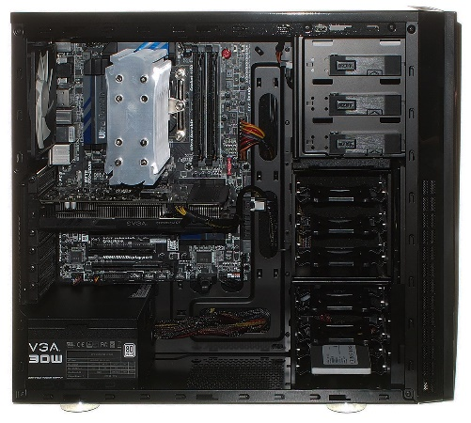

1. Clearly label the following components (using arrows) on your image of the PC case internals:
   1. Motherboard
   2. Power Supply
   3. Hard Disk Drive
   4. Optical Disk Drive (e.g.DVD)
   5. USB Expansion Ports
   6. Monitor Port
   7. Audio Ports
   8. Ethernet Port
   9. Cooling Fan

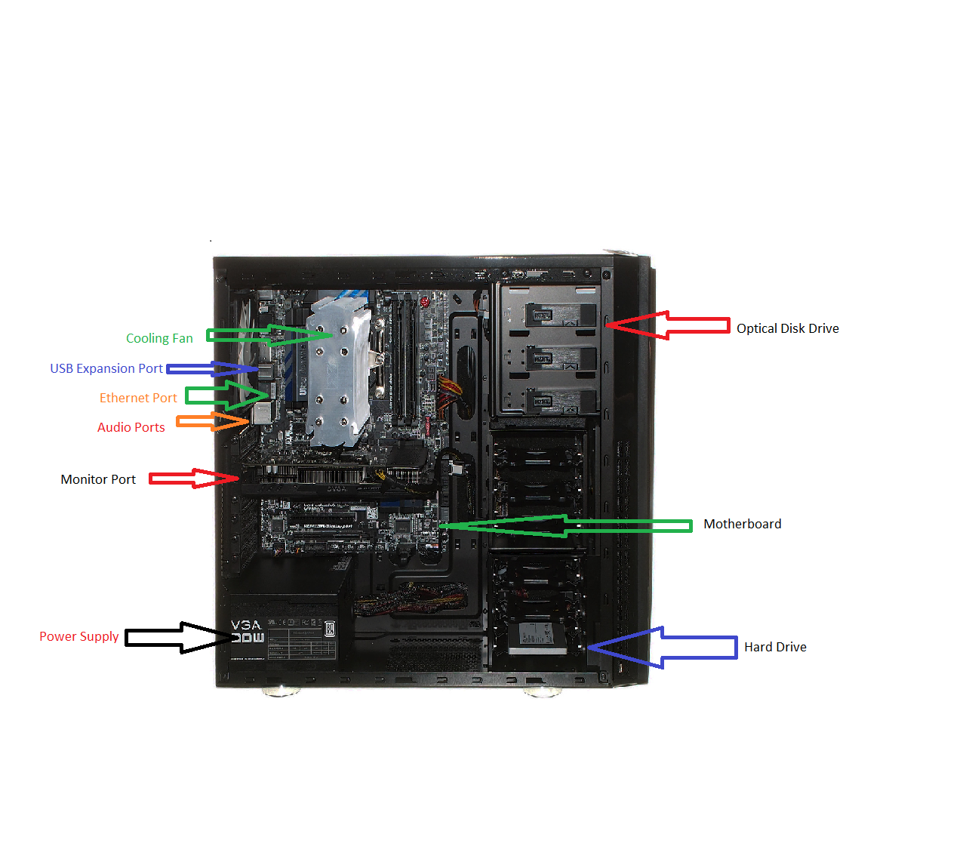

1. Research more in-depth about “Motherboards”. Make notes on the following:
   1. What different versions are currently available (speed and capacity)

Currently, most desktops or laptops contain an ATX motherboard in which is the layout, design and size of the motherboard. However, motherboards do not form any sorts of speed due to its main function is to hold each of the ports, cables, processor and ram together. The motherboard does not form any kind of speed.

* 1. How the component has changed since the 1980’s

The motherboard which was firstly known as the Planar Breadboard was brought into the technology world at 1981 by IBM. The Planar had chips which was only used to connect the CPU and RAM of the computer together. They were connected by cassette tapes and supplier parts. The Planar motherboard was also called the “IBM compatible” standard like many other modern-day motherboards. Present day motherboards are significantly different from the IBM motherboard due to the immense features of the newer motherboards like adding integrated circuit packaging in 1990 and including peripherals like the mouse and keyboard. Furthermore, including the mouse and keyboard with the motherboard gave both devices lower power consumption so it would not consume the power of the desktop. Most monitors now come in various sizes and perform many different functions/features. Higher grade motherboards can now help boost performance in any sorts of tasks.

1. Research more in-depth about “Hard Disk Drives”. Make notes on the following:
   1. What different versions are currently available (speed and capacity)

Hard Disk Drives range from 5400 rpm to 7200 rpm. These drives can also expand from 500GB to 6 TB.

* 1. How the component has changed since the 1980’s  
       
     Since the 1980’s many components have been changed by having expandable storage. At the start of the 1980’s a common hard disk drive will be around 10 MB with very slow speeds which is unnoticeable with today’s technology. Later on in the 1990’s, hard drives have varying sizes which each computer can then put into the hard drive slots.

**NOTE:**

* Download the on-line version of this module (from the class GitHub repository)
* Questions for Level 2 and Level 3 are in the on-line version of this module
* Provide your answers in a MS Word, PowerPoint, or equivalent format
* Upload your answers to your personal GitHub repository

**Level 2: PC Motherboard**

**Outline**

Learn about the structure of a standard PC motherboard by examining physical samples and selecting and labeling images found on-line. Gain deeper knowledge by researching and reporting on specific components.

**Questions**

1. Find one (or more) images that clearly show the layout of a PC Motherboard.   
   (i.e. Google images using keywords “PC Motherboard”)

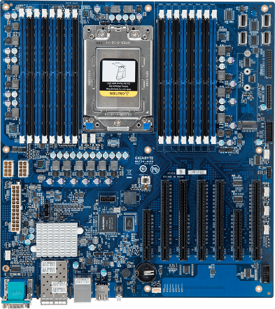

1. Clearly label the following components (using arrows) on your image of the PC motherboard:
   1. CPU (and fan)
   2. RAM Memory
   3. Disk Drive Interface (IDE or SATA)
   4. GPU Graphics Processor (either on-board or Graphics Card)
   5. Sound Processor (either on-board or Sound Card)
   6. Wi-Fi / Ethernet Network Interface (either on-board or Graphics Card)

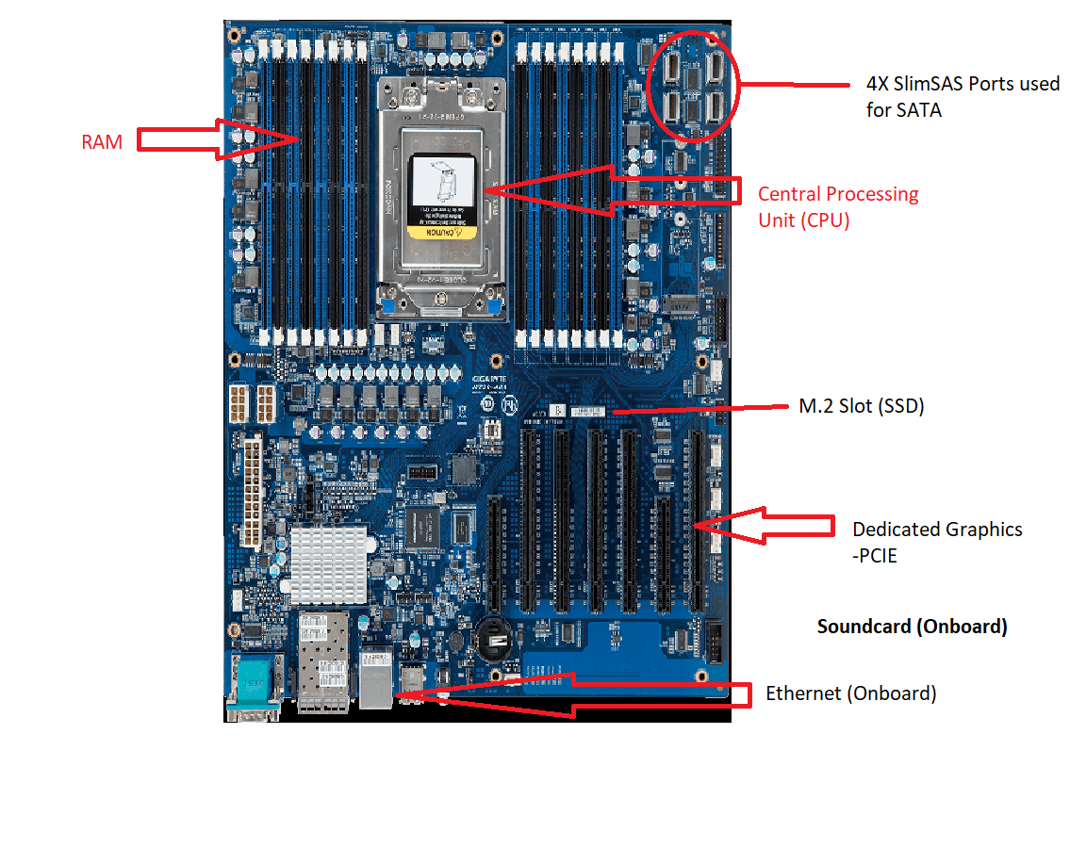

1. Research more in-depth about “CPU Processor Chip”. Make notes on the following:
   1. What different versions are currently available (speed and capacity)

The processor chip in todays age has many kinds of varying speeds and different kinds of core counts. Today, most chips contain only 4 cores with 3.4 Ghz Furthermore, usually better processors have much higher speeds and core counts but is usually is worth a lot of money. Certain processors have a 6-core processor which can range from 8-32 cores. The speed of any kind of CPU can range from 2.9 Ghz – 4.9 Ghz. In addition, the processor can overclock up to 8 Ghz at maximum.

* 1. How the component has changed since the 1980’s

Since the 1980’s, the CPU had undergone many changes. Before, the CPU had only 1 core which ran at 6 Mhz which is significantly low compared to the modern-day processors. 10 years later during 1990, the speeds of the core slightly increased to 8 Mhz. Later on in 1990, the speed increased to 20 Mhz. Furthermore in 1995, the multi core processor was introduced to help build more processing power and functions. Overtime, the CPU started to increase in its speed and cores to make processing much quicker and bring much quicker speeds to any sort of task.

1. Research more in-depth about “RAM Memory”. Make notes on the following:
   1. What different versions are currently available (speed and capacity)

RAM has evolved a lot over the years. The most common ram found in most computers is usually 6-8 GB as higher ram cost a lot more. The current generation of ram contains DDR4 memory which can achieve higher speeds and memory. RAM could increase to 16, 32, 64 and even 128 GB which can roughly cost around $1000. The standard speed of RAM is 2000 Mhz. The speed of ram could get up to 3200 Mhz.

* 1. How the component has changed since the 1980’s  
       
     RAM has significantly changed since the 1980’s. From 1982-1984 RAM was only 1 KB to 16 KB. From 1985, RAM has reached 512Kb to 612 KB. However, the speed of the RAM has stayed the same throughout each of the years at 20 Ghz. From 1995-1999, RAM has increased from 32 MB and 128MB with a speed of 25 Mhz. From then on RAM has began to increase over the 2000’s.

**Level 3: Peripheral Devices**

**Outline**

Learn about how peripheral devices are connected to the back side of a typical PC tower case. Examine physical samples, select and labeling images found on-line and gain deeper knowledge by researching and reporting on specific components.

**Questions**

1. Find one (or more) images that clearly show the layout of the back of a typical PC tower case.   
   (i.e. Google images using keywords “Back Of PC Tower”)

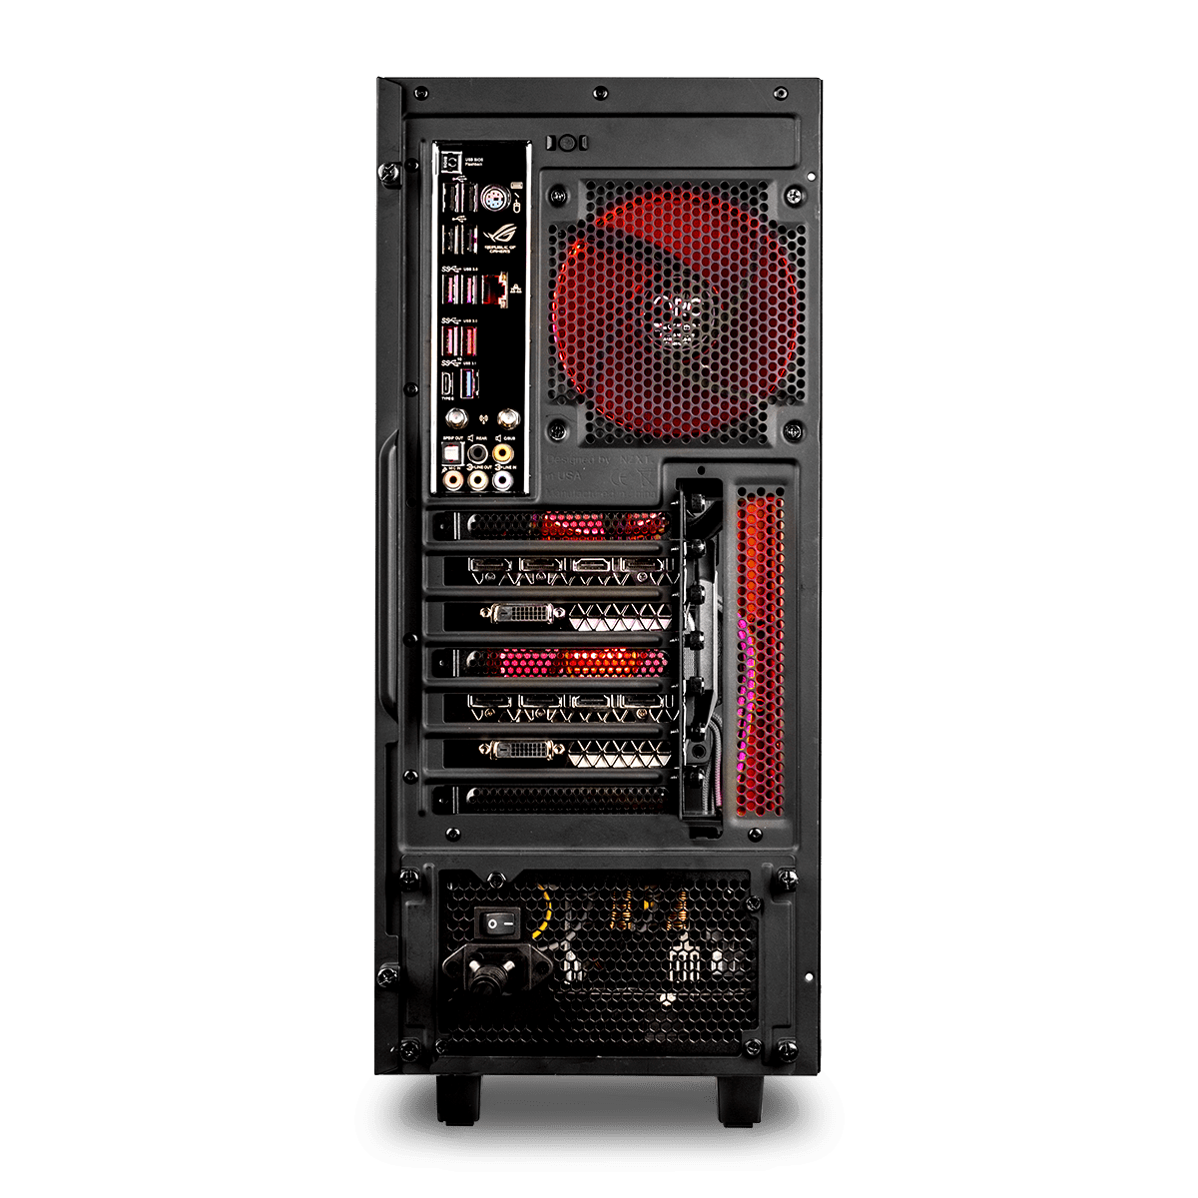

1. Clearly label the following components (using arrows) on your image of the back of a typical PC tower case:
   1. Power cord and power switch
   2. Monitor Interface (VGA or DVI or HDMI)
   3. Mouse Interface (USB or PS/2)
   4. Keyboard Interface (USB or PS/2)
   5. USB Ports
   6. Audio Inputs / Outputs
   7. Ethernet Interface

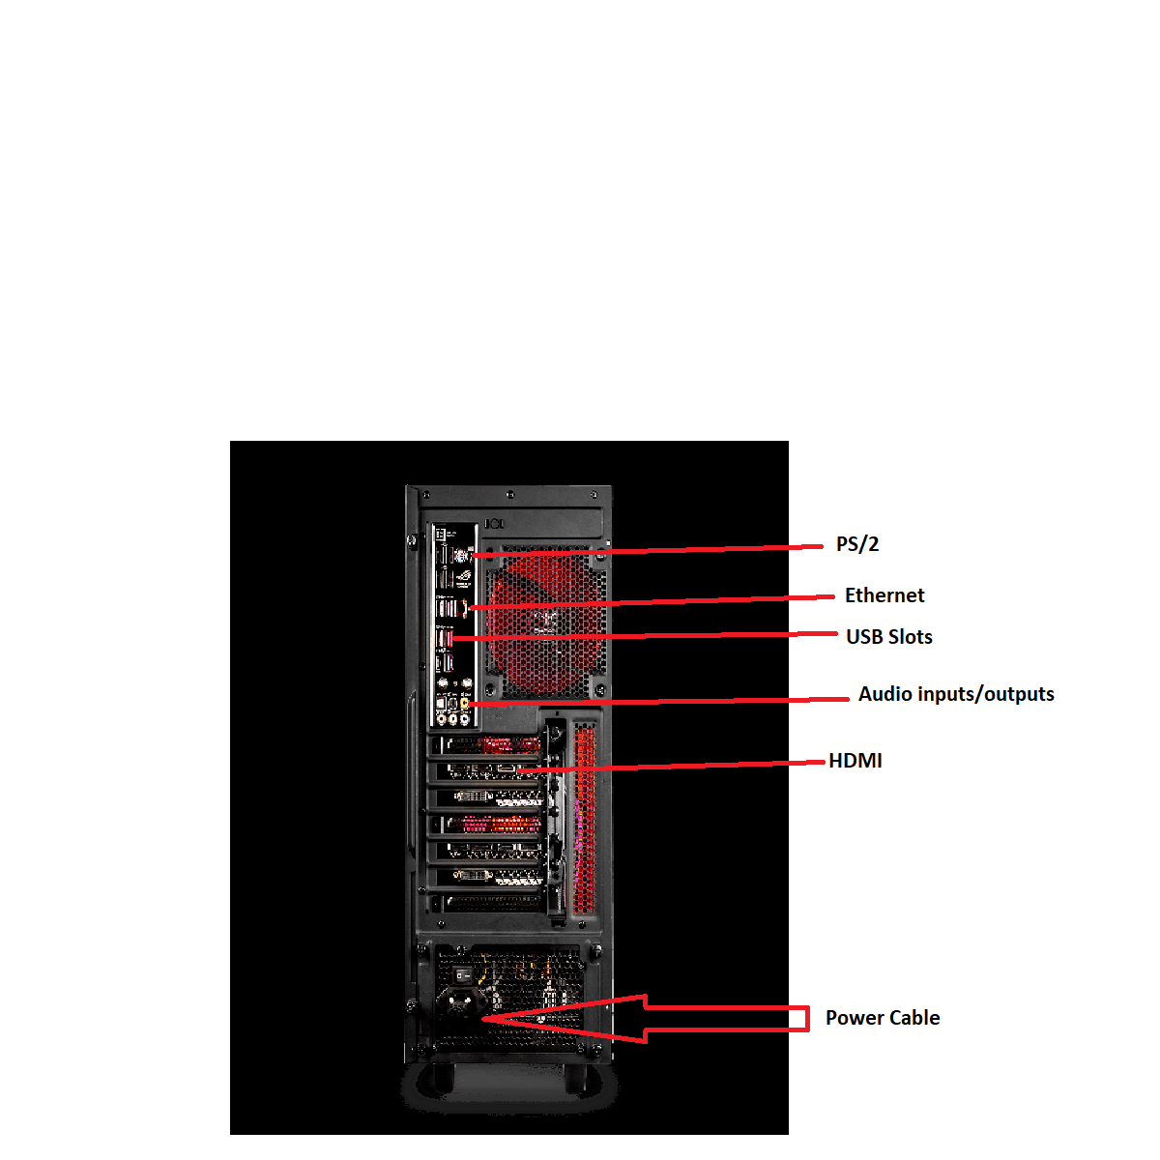

1. Research more in-depth about “Monitor Technology”. Make notes on the following:
   1. What different versions are currently available (e.g. VGA / DVI, Flat Panel Technology))

There are many kinds of Monitor Technology. Monitor Technology has HDMI ports to help give a display for the monitor. Monitor Technology also includes a display port to display the image. Monitors have a variety of resolutions on pixel and pixel quality. The best being 4K (3840 x 2160) to display better pixel inch to bring much crisp and sharper looks. The more dots per inch there is, the higher the image quality will be. Commonly, most monitors contain a native type of resolution namely 1920x1080p and 2560x1440p. Monitors also has different kinds of panels like the flat and curved. Finally, monitors can be classified either as LED or LCD. LED’s being more better for having better power consumption and energy efficiency while LCD is just a basic technology which is used in television.

* 1. How the component has changed since the 1980’s (e.g. Display Resolution, Technology)

Monitors have significantly changed from the 1980’s. Back then, monitors had very low resolution which provides low quality images which can only display black and white or black and green colors. These monitors back then were a CRT type (Cathode Ray Tube). Later on around 2003 and 2004, LED monitors were introduced to provide much higher quality images and higher resolutions to bring a more lively experience to the viewer.

1. Research more in-depth about “External Portable Storage”. Make notes on the following:
   1. Floppy Disks- Magnetic disk that were used in the past for storing programs and data. Does not have much space.
   2. CD-ROM / DVD / Recordable CD/DVD- A lazer written, compact disk in which is used as storage.
   3. USB Memory Drives- Universal Serial Bus. Small device which can hold large amounts of data.
   4. Compact Flash Memory- Used to store the images taken from cameras. Can be from 1GB to 128GB
   5. Cloud Based Storage- A paid service used by a variety of companies in which can be used to access data from anywhere online.

**Level 4: PC Component Presentation**

**Outline**

Explore the development and features of a specific PC hardware component through deeper research and investigation. Work in partners to create a short presentation. Deliver the presentation to the class.

Each group will research a unique PC hardware component . Your specific topic will be assigned from the list provided below.

**Presentation Structure**

1. Explain what the PC component does and how it fits together with other components to make up a fully functioning PC.
2. Explain how the PC component works. Provide a diagram (image) showing the main parts of the component.
3. Research the current state of the art of the component in terms speed, capacity (size), and other related factors.
4. Research on-line suppliers that sell the PC Component. List the specifications for the available products and the cost (price).
5. Research how the PC component has changed and evolved since the early days of PCs in the 1980’s. Cover each of the following topics separately:
   1. Component Speed
   2. Component Size / Capacity
   3. Two other specifications specific to the PC component (ask Mr. Nestor)

**PC Component Topics**

|  |  |  |
| --- | --- | --- |
| **Topic** | **Partner 1** | **Partner 2** |
| CPU Microprocessor Chip |  |  |
| Motherboard Layout |  |  |
| Computer Graphics |  |  |
| Sound & Audio |  |  |
| Hard Disk Drives |  |  |
| Removable Disk Storage |  |  |
| Network / Internet Connectivity |  |  |
| Mouse / Pointing Devices |  |  |
| Monitor & Display Technology |  |  |
| Printers & Output Technology |  |  |